**User Manual of Case Type:**

Case Type Form:

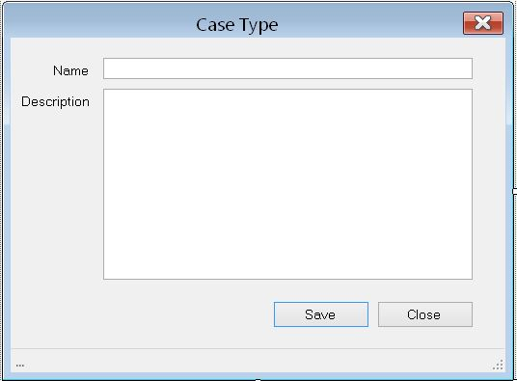

User can add name and the description by using this form.